

American International University-Bangladesh (AIUB)  
**Department of Computer Science  
Faculty of Science & Technology (FST)**

**Bicycle rent management**

A Software Engineering Project Submitted

**ToFARZANA BENTE ALAM**

|  |  |  |  |  |
| --- | --- | --- | --- | --- |
| **Semester: Fall_24_25** | | **Section: B** | **Group Number:07** | |
| SN | Student Name | Student ID | Contribution (CO3+CO4) | Individual Marks |
| 1 | MD. TANJIL TASHRIK ZIM | 22-48021-2 | 20% |  |
| 2 | MD. AL-IMRAN SAYEM | 22-48023-2 | 20% |  |
| 3 | S.M. RASEL | 22-48039-2 | 20% |  |
| 4 | MD. ABRAR RAFID SHARIAR | 22-48055-2 | 20% |  |
| 5 | Abdullah Al Maruf | 22-47997-2 | 20% |  |

The project will be Evaluated for the following Course Outcomes

|  |  |  |
| --- | --- | --- |
| **CO3:** *Select* appropriate software engineering models, project management roles and their associated skills for the complex software engineering project and evaluate the sustainability of developed software, taking into consideration the societal and environmental aspects | Total Marks | |
|  | |
| Appropriate Process Model Selection and Argumentation with Evidence | [5 Marks] |  |
| Evidence of Argumentation regarding process model selection | [5Marks] |  |
| Analysis the impact of societal, health, safety, legal and cultural issues | [5Marks] |  |
| Submission, Defense, Completeness, Spelling, grammar and Organization of the Project report | [5Marks] |  |
| **CO4:** *Develop* project management plan to manage software engineering projects following the principles of engineering management and economic decision process | Total Marks | |
|  | |
| Develop the project plan, its components of the proposed software products | [5Marks] |  |
| Identify all the activities/tasks related to project management and categorize them within the WBS structure. Perform detailed effort estimation correspond with the WBS and schedule the activities with resources | [5Marks] |  |
| Identify all the potential risks in your project and prioritize them to overcome these risk factors. | [5Marks] |  |

|  |  |  |
| --- | --- | --- |
| **CO5:** **Perform as an effective team member or leader in diverse team settings and solve multi-disciplinary problems in the computer science and engineering domain** | Total Marks | |
|  | |
| Taking project responsibility: perform assigned tasks on time independently | [5 Marks] |  |
| Contribution to project group meetings, sharing fruitful ideas | [5Marks] |  |
| Positive attitude towards group work, collaboration, compromise, helping others to understand their project work responsibility | [5Marks] |  |
| Showing respect and value towards other team member's opinion | [5Marks] |  |

Description of Student’s Contribution in the Project work

|  |
| --- |
| Student Name: MD. TANJIL TASHRIK ZIM  Student ID: 22-48021-2  Contribution in Percentage (20%):  Contribution in the Project:   * Proposal * Process Model * Functional Requirements * Use case Diagram * Class Diagram * Activity Diagram * Sequence Diagram * Mobile App Design * WBS * Risk Management   ZIM  ___________________  Signature of the Student |
| Student Name: MD. AL-IMRAN SAYEM  Student ID: 22-48023-2  Contribution in Percentage (20%):  Contribution in the Project:   * Proposal * Process Model * Functional Requirements * Use case Diagram * Class Diagram * Activity Diagram * Sequence Diagram * Test Case * Time Line Chart 2 * Risk Management     SAYEM  __________________  Signature of the Student |
| Student Name: S.M. RASEL  Student ID: 22-48039-2  Contribution in Percentage (20%):  Contribution in the Project:   * Proposal * Process Model * Functional Requirements * Use case Diagram * Class Diagram * Activity Diagram * Sequence Diagram * Test Case * Time Line Chart 1 * EVA Calculation   RASEL  ___________________  Signature of the Student |
| Student Name: MD. ABRAR RAFID SHARIAR  Student ID: 22-48055-2  Contribution in Percentage (20%):  Contribution in the Project:   * Proposal * Process Model * Functional Requirements * Use case Diagram * Class Diagram * Activity Diagram * Sequence Diagram * Test Case * Time Line Chart 1 * Time Line Chart 2   SHARIAR  _________________  Signature of the Student |
| Student Name: Abdullah Al Maruf  Student ID: 22-47997-2  Contribution in Percentage (20%):  Contribution in the Project:   * Proposal * Process Model * Functional Requirements * Use case Diagram * Class Diagram * Activity Diagram * Sequence Diagram * Mobile App Design * Eva Calculation * WBS   Maruf  __________________  Signature of the Student |

**1. PROJECT PROPOSAL**

**1.1 Background to the Problem**

Urbanization has led to significant transportation challenges, including traffic congestion, pollution, and increased costs, impacting quality of life in cities. Cycling offers a sustainable, health-promoting alternative but requires accessible infrastructure to be practical for daily commutes. The Bicycle Management System meets this need by establishing bike hubs in high-traffic urban areas, enabling seamless bicycle access for residents and tourists. Aimed at reducing traffic, minimizing pollution, enhancing wellness and carbon emission reduce the system combines technology with urban planning to support cycling as a viable transit option, promoting greener, healthier, and more connected urban spaces. It provides financial benefits by keeping operational costs low and offering affordable transportation, encouraging more usage and boosting revenue. Predictive maintenance extends bike lifespan, reducing repair costs. Flexible pricing, like peak-hour rates and off-peak discounts, balances bike availability and enhances income. Additionally, sponsorships and advertising from local businesses provide supplemental revenue. This model not only ensures the system's financial sustainability but also reduces urban infrastructure costs, benefiting both operators and cities.

The root causes of low cycling infrastructure and uptake in Bangladesh are multi-faceted, including urban planning challenges, traffic safety concerns, and social perceptions. Here’s why this problem is essential to address: **Traffic Congestion**: Major cities like Dhaka suffer from heavy traffic congestion. Cycling can be a viable, space-efficient alternative for short commutes, potentially reducing road congestion significantly. **Environmental Impact**: Air pollution is a severe problem in urban areas of Bangladesh. Encouraging cycling, which produces zero emissions, could help reduce pollution levels, making the air cleaner and healthier. **Health Benefits**: Cycling offers a cost-effective way to promote public health. With rising rates of non-communicable diseases, such as diabetes and heart disease, encouraging cycling can be a practical means to improve fitness and overall well-being. **Economic Savings**: For a densely populated country like Bangladesh, promoting cycling can reduce dependency on fossil fuels and cut transportation costs, especially for low-income groups who spend a significant portion of their income on transportation. **Climate Change Resilience**: With Bangladesh’s vulnerability to climate change, promoting sustainable transportation like cycling aligns well with national goals for resilience and reducing carbon emissions. Addressing these root causes requires investments in cycling infrastructure, road safety measures, and awareness campaigns to make cycling a safe, attractive, and socially accepted mode of transportation across all social and economic classes.

**1.2 Solution to the Problem**

The objective of the "Bicycle Management System" is to provide a convenient, affordable, and eco-friendly solution for short-distance travel by making bicycles easily available for rent. This project addresses issues of urban congestion, high transportation costs, and environmental pollution by promoting bicycle use over other modes of transport. Solutions include developing a user-friendly platform where customers can rent bicycles, integrated with online payment options like QR code scanning for ease. The system will offer real-time tracking and designated pick-up/drop-off locations to improve accessibility and safety. Additionally, a maintenance tracking feature will ensure that bicycles are in good condition, enhancing service quality and user experience. This approach aims to make short-distance travel more sustainable, cost-effective, and health-oriented.

Proposed Solutions: The Bicycle Management System will offer a rental platform with features like online payments, real-time tracking, and flexible pick-up/drop-off points. Users can locate and rent nearby bicycles conveniently through the app, paying digitally or via QR code. The system will also track bicycle usage for maintenance, ensuring a safe and reliable experience. Solution Appropriateness: This solution is suitable because it directly addresses the need for flexible, eco-friendly transportation options, reducing traffic congestion and pollution. By making rentals accessible and affordable, it appeals to users who prefer convenient, short-distance travel without relying on cars or crowded public transport. Feasibility: The solution is feasible for meeting business objectives as it provides a scalable, user-centered service with low operational costs compared to other transport models. The digital integration of payments and tracking enhances user experience, and the system’s flexibility promotes widespread adoption, aligning with sustainability goals and financial viability.

The "Bicycle Management System" uses state-of-the-art technology to offer a smart, efficient, and impactful bicycle rental solution. Key functionalities include a mobile app that enables users to locate, reserve, and unlock bicycles through GPS tracking and Bluetooth or QR code scanning. This real-time tracking feature not only streamlines the rental experience but also enhances safety and security by monitoring bicycle locations, preventing loss or theft. Digital payment integration—allowing online payments and QR-based transactions—makes rentals quick and cash-free, increasing accessibility for a diverse range of users and providing flexibility for payments. This solution has the potential to make a significant societal impact. By promoting cycling, it encourages eco-friendly transport, reducing carbon emissions and improving air quality. Health benefits are also notable, as cycling offers a practical, daily way for users to incorporate exercise into their routines. The system’s maintenance alerts ensure that bicycles remain safe and well-maintained, addressing safety concerns that could deter potential riders. Furthermore, the solution addresses legal and cultural issues by complying with local traffic and rental regulations, promoting a responsible sharing culture, and helping to decongest urban areas. By integrating advanced technology, this solution not only meets transportation needs but also supports environmental, health, and community goals, providing a creative and sustainable approach to real-world challenges.

The target group for the "Bicycle Management System" includes urban commuters, tourists, students, and anyone needing convenient, short-distance travel options. These users often require flexible transportation that is cost-effective, eco-friendly, and time-saving. Urban commuters will benefit from reduced travel times and costs for short trips, avoiding the hassle of traffic and parking. Tourists can explore cities affordably, enjoying a healthier, immersive experience without needing a car. Students benefit from easy access to bicycles on campus or nearby locations, allowing them to navigate quickly without relying on cars or public transit. By using this solution, users gain access to a reliable, sustainable transport mode that promotes health through exercise and reduces dependency on fuel-based transportation. Additionally, the convenience of digital payments and real-time tracking improves the rental experience, making it simple, safe, and accessible for a wide range of users. Overall, the system fosters a lifestyle shift towards greener, more active, and economically friendly travel options.

The "By-Cycle Management System" contributes to scientific development by showcasing how technology-driven mobility solutions can transform urban transportation. It integrates advancements in GPS, IoT, and mobile payment systems to create a seamless, user-centered experience, demonstrating the potential for these technologies to address real-world problems like urban congestion, pollution, and lack of accessible transport. Through data collection on user behavior, travel patterns, and bicycle usage, the project provides valuable insights into the effectiveness of micro-mobility solutions, contributing to research on sustainable urban mobility and transportation planning. This data-driven approach allows for evidence-based decisions in urban design and policy, documenting how bicycle-sharing systems can impact health, environmental, and economic outcomes. The project’s comprehensive approach—blending technology with transportation needs—serves as a documented case study on the practical application of state-of-the-art technology to achieve sustainability goals. Its results can inform future innovations and developments in shared mobility systems, advancing scientific understanding of how technology can contribute to urban resilience and green infrastructure.

The topic of bike-sharing and cycle rental systems has been widely discussed, with many studies highlighting the benefits of bicycle rentals for reducing urban congestion, promoting eco-friendly transportation, and offering affordable travel options. Early discussions emphasized how bike-sharing systems could positively impact air quality, decrease fuel consumption, and encourage physical activity. Additionally, other works explored common issues in bike-sharing, such as limited rental station availability, maintenance challenges, and a lack of flexible payment methods. More recent studies have discussed the role of technology in improving bike-sharing systems, like GPS tracking and mobile apps for bike reservations. These studies showed that implementing real-time tracking, digital payment options, and maintenance features could enhance user satisfaction and expand the reach of these systems. However, there has often been less focus on making the system highly user-centered and personalize to meet diverse user needs. Our study extends the existing work by creating a fully app-based, user-centered system that integrates real-time tracking, QR code unlock features, and flexible digital payments for added convenience. We address the gaps by incorporating predictive maintenance based on bicycle usage data, which helps keep bicycles safe and available. By allowing users to create profiles and track their rental history, our solution offers a personalized experience while supporting environmental goals, filling critical gaps in previous approaches and setting a comprehensive model for the future of bike-sharing systems.

In the area of bicycle-sharing and rental systems, several studies and software solutions have been developed to address urban transportation issues, such as traffic congestion, pollution, and the need for affordable short-distance travel options. Key studies have demonstrated the positive impacts of bike-sharing systems on sustainability, health, and city mobility. These works outline the benefits of integrating cycling into public transit systems and underscore how bike-sharing can reduce the dependency on private vehicles. They have also explored how technology, such as real-time tracking, mobile app reservations, and payment integrations, can enhance user experience and service accessibility. Existing software solutions in the bike-sharing space include applications like Pathao, Uber, Indrive etc. These platforms allow users to locate, reserve, and unlock bikes via mobile apps, often using GPS tracking and QR code features. Lime and Citi Bike, for example, offer dockless bike-sharing, enabling users to pick up and drop off bikes at various locations, providing greater flexibility and convenience. These systems generally include digital payment options, making it easy for users to rent bikes without needing cash, and they often provide maintenance alerts to ensure bike quality. However, while these solutions have improved access to shared bikes, challenges remain. Issues like limited availability in less populated areas, high maintenance costs, and inconsistent user experience can hinder broader adoption. Our project aims to build upon these existing solutions by focusing on enhanced user personalization, predictive maintenance using data analytics, and integrating multiple payment and tracking features to create a more comprehensive, user-centered platform that addresses these gaps and promotes sustainable urban commuting.

Existing software solutions for bike-sharing generally allow users to locate, reserve, and unlock bicycles through mobile applications, often using GPS tracking and QR code scanning for accessibility. These platforms typically support digital payments and provide either docked bike models, enabling flexible rentals. They may also incorporate maintenance alerts to ensure bike safety and functionality for users, addressing core needs like convenience and security. However, these systems often face limitations, such as inconsistent availability in certain areas, high operational costs, and a lack of personalized features like tailored rental histories or adaptive pricing. Our proposed solution builds on these by offering a more user-centered experience, with features such as individual user profiles, tracking of rental history, predictive maintenance based on real-time usage data, and flexible payment options including QR codes. This comprehensive approach not only enhances user satisfaction and loyalty but also improves accessibility, safety, and the long-term sustainability of the system.

**2.1 Process Model:**

The proposal in the file describes a "Bicycle Rent Management System" designed to address transportation challenges in urban environments through a software-driven bike-sharing solution. Now, let's dive into why the Waterfall model might be a suitable choice for this project and how it compares to other development methodologies like the Prototyping Model, V-Model, Incremental Model, and Component-Based Development Model.

**Waterfall Model Overview:** The Waterfall model is a linear sequential software development process where progress flows steadily downwards through distinct phases such as requirements gathering, design, implementation, verification, and maintenance. This approach is highly structured and easy to manage due to its sequential nature.

**Applicability to Bicycle Rent Management System:**

* **Clarity of Requirements:** The project requirements, as laid out, are clearly defined and well understood, making it easier to follow the structured phases of the Waterfall model.
* **No Iterative Development:** Given that the project requirements are unlikely to change once they are defined, the Waterfall model provides a straightforward approach to development without the need for iterative revisions.
* **Regulatory Compliance:** The model allows for thorough documentation at each stage, which can be beneficial for meeting any regulatory requirements and maintaining clear project records.

**Comparison with Other Models**

1. **Prototyping Model:**
   * **Not Used Because:** While it allows for early user feedback by developing a working model of the system, it may lead to scope creep as continuous changes and iterations can significantly alter the project scope or lead to increased costs.
2. **V-Model:**
   * **Not Used Because:** It’s similar to Waterfall but with a stronger emphasis on testing at each stage of development. For a project like this, where requirements are well-defined and unlikely to change, the additional overhead of the V-Model's validation and verification might not be necessary.
3. **Incremental Model:**
   * **Not Used Because:** This model involves delivering the product through incremental builds. While it allows flexibility in accommodating changing requirements, it might be overkill for projects with stable requirements like this one.
4. **Component-Based Development Model:**
   * **Not Used Because:** This model focuses on reusing existing software components, which might not be applicable if the project requires specific customizations or if suitable components are not available.

**Advantages:**

* **Simplicity and Ease of Use:** The linear nature of the model makes it easy to understand and manage.
* **Defined Stages:** Clear project milestones and deliverables.
* **Suitability for Small Projects:** Ideal for projects with fixed requirements and shorter durations.

**Disadvantages:**

* **Inflexibility:** Difficulty in accommodating changes once the project has started.
* **Delayed Testing:** Testing only occurs after the build stage, which might delay the detection of issues.
* **Risk of Misalignment:** If initial requirements are not thoroughly understood, the final product may not meet stakeholders’ expectations.

**Waterfall Model Process for the Bicycle Rent Management System**

Here's a breakdown of the Waterfall process tailored to your project proposal:

1. **Requirements Analysis:** Gather detailed specifications for the bicycle rent management system, including functional and non-functional requirements.
2. **System Design:** Architect a solution that incorporates both hardware (bikes, locks) and software (app, payment system) components.
3. **Implementation:** Develop the software components as outlined in the design phase, including app development and integration with payment gateways.
4. **Verification:** Conduct thorough testing to ensure that all components work together seamlessly and meet the project requirements.
5. **Maintenance:** After deployment, continue to provide support and updates, addressing any issues that arise during operation.

By aligning the Waterfall model with your project’s specific needs, you can leverage its structured approach for efficient project management and delivery.

* 1. **Project Roles and Responsibilities:**

1. **Product Owner**
   * Defines the project goals and ensures alignment with stakeholders' needs.
   * Manages the product backlog and sets priorities for system functionalities, including cycle reservation, and payment integration.
   * Collaborates with the team to set sprint goals and ensures clarity of deliverables.
2. **Scrum Master**
   * Facilitates scrum practices and ensures adherence to the Waterfall methodology used for this project.
   * Removes obstacles faced by the development team, such as delays in requirements or resource issues.
   * Organizes team meetings and ensures smooth communication among team members.
3. **Development Team**
   * Responsible for coding, testing, and integrating features like real-time bike availability, secure payment options, and GPS-enabled tracking.
   * Develops user interfaces for apps and dashboards and implements backend systems for secure data management.
   * Conducts iterative testing to ensure functionality and user experience.
4. **Customer** 
   * Provides feedback on core functionalities, such as damage reporting, smart lock integration, and route planning.
5. **Management**
   * Oversees overall progress, allocates resources, and provides final decision-making authority.
   * Addresses project risks and ensures adherence to budgetary and timeline constraints.
   * Supports stakeholder engagement and ensures sustainability of the project outcomes.
6. **Quality Assurance (QA)**
   * Validates all features, such as the emergency assistance button, reward program, and return station locator, for accuracy and reliability.
   * Performs unit testing, system testing, and user acceptance testing before deployment.
7. **User Experience (UX) Designer**
   * Designs intuitive interfaces for the app, including multilingual support and real-time notifications.
   * Ensures a seamless user journey from sign-up to bike return.
   * Conducts usability testing to improve overall user satisfaction.
8. **Support and Maintenance Team**
   * Provides in-app customer support through live chat and FAQ updates.
   * Manages issues such as technical malfunctions, user complaints, and system downtimes.
   * Continuously updates features based on user feedback and technological advancements.

**Functional Requirements:**

**Mobile App Access:** Users can start by downloading the By-Cycle app on both Android and iOS platforms or visiting the official website.

**User Sign-Up and Agreement Form:**

* The software will provide a secure signup function, requiring specific input details for all users. Users will undergo identity verification and must agree to liability terms.

For All Users:

* + - Name
    - Email
    - Phone Number
    - National ID (NID)
* **Verification Code**: After providing these details, the system will send a verification code to the user’s email or phone to confirm identity.
* **Password Setup**: Users will be prompted to create a secure password following verification.
* **Agreement to Terms of Service:** During signup, users must agree to the Terms of Service, which include a liability agreement stating that any bike damage will require compensation from the user. This agreement ensures accountability for maintaining bike conditions.

Upon successful signup, the user can access the By-Cycle Management System and proceed to select a membership plan or start using the service.

* **Priority Level**: High
* **Precondition**: User must have a valid email, phone number, and NID.

**Real-Time Bike Availability:**

The user dashboard provides real-time access to cycle availability across hubs, helping users plan rides efficiently.

* **Cycle Availability Check:** Users can view live updates on cycle availability at nearby hubs. Each hub is color-coded to indicate availability levels:
* **Green:** High availability
* **Yellow:** Moderate availability
* **Red:** Low availability
* **Bike Reservation Option:** Users may reserve a bike for a short period to ensure it’s available upon arrival at the hub, adding convenience and reliability to their experience.

This intuitive dashboard design enables users to assess availability at a glance and secure bikes as needed.

**GPS-Enabled Tracking:**

The system incorporates GPS tracking to enhance navigation, security, and bike management.

* **Route Navigation:** Users can access GPS-enabled navigation to find optimal routes, improving convenience and safety during their rides.
* **Bike Security and Retrieval:** GPS tracking provides real-time location data, allowing operators to monitor bikes for security purposes. This feature also aids in retrieving bikes in cases of improper returns or potential theft.

Integrated GPS tracking not only benefits users by simplifying navigation but also ensures accountability and easy recovery of bikes within the system.

**Secure Payment Options:**

The app provides multiple secure payment methods to ensure a smooth transaction experience for users, catering to a variety of preferences:

* **Mobile Banking:** Users can make payments through popular mobile banking services such as **bKash, Nagad**, and **Rocket**, offering a fast and widely accessible option for local users.
* **Credit Cards:** The app supports major credit card payments, ensuring secure and versatile payment options for users.
* **Digital Wallets:** Integration with digital wallets allows for easy, mobile-based payments, enhancing convenience for frequent users.

These options enable a flexible and seamless payment process, enhancing user satisfaction and accessibility.

**Damage Reporting and Photo Upload:**

The app includes a damage reporting feature to ensure accountability and transparency for bike condition.

* **Damage Reporting:** Users can report any visible damage on the bike both **before and after their rides. This proactive reporting process helps document the bike's condition and maintains clear records.
* **Photo Upload:** Users can upload photos of the bike to visually confirm its condition. This feature assists in verifying whether the bike was returned in good shape and provides a reference for resolving any disputes over damage.

This feature enhances accountability and supports fair handling of damage claims.

**In-App Customer Support:**

The app offers a dedicated support feature to ensure users have access to real-time assistance and helpful resources.

* **Live Chat:** Users can connect with customer support via live chat for instant help with bookings, technical issues, or general inquiries, providing prompt and personalized assistance.
* **Issue Reporting:** Users can report specific problems (e.g., bike malfunction, payment issues) directly within the app, streamlining the resolution process.
* **FAQ Section:** A comprehensive FAQ section addresses common questions, allowing users to find quick answers on topics like payment options, reservation policies, and bike availability.

This in-app support feature enhances user experience by offering convenient and immediate help, ensuring smooth and reliable service.

**Usage Timer and Billing:**

The app includes a built-in usage timer to help users manage rental time and costs efficiently.

* **Rental Duration Tracking**: A timer starts automatically once the bike is rented, tracking the exact duration of use.
* **Fee Calculation**: Based on the rental duration, the app calculates fees in real time, providing users with transparent and up-to-date cost information.
* **Time Limit Notifications**: The app sends notifications when users are approaching time limits, helping them avoid extra charges and manage rental costs effectively.

This feature promotes cost-effective usage, enhancing user control and transparency in billing.

**Return Station Locator:**

The app includes a return station locator to simplify the bike drop-off process for users.

* **Nearest Station Highlighting**: The app automatically identifies and highlights the nearest available return stations based on the user’s current location, ensuring convenience.
* **Real-Time Availability**: Each station shows real-time dock availability, so users can easily find a station with open docking spots for bike returns.
* **Directions to Station**: The app provides GPS directions to the chosen return station, helping users navigate quickly and efficiently.

This feature ensures an easy and hassle-free bike return experience by guiding users to the most convenient and accessible stations.

**Reward Program:**

The app includes a reward program to encourage responsible and frequent use of the bike-sharing service.

* **Earning Points**: Users accumulate points for various actions, such as:
  + **Frequent Rentals**: Earn points for regular usage.
  + **Bike Condition**: Receive points for returning bikes without damage.
  + **On-Time Returns**: Gain points for returning bikes within the allotted time.
* **Redeeming Points**: Collected points can be redeemed for exclusive benefits like **discounts on future rides** or **free ride vouchers**.

This reward system promotes user loyalty, responsible usage, and timely returns while offering savings and incentives to users.

**Weather and Safety Notifications:** The app provides weather and safety alerts to ensure a secure and comfortable riding experience.

* **Weather Alerts**: Users receive real-time notifications about sudden weather changes, such as rain, storms, or extreme temperatures, helping them make informed decisions about their rides.
* **Safety Guidelines**: The app sends reminders for safety measures (e.g., wearing helmets, avoiding busy roads) and area-specific advice, especially helpful for tourists navigating unfamiliar locations.
* **Alternative Suggestions**: In cases of severe weather, the app may suggest alternative transportation options or the nearest safe shelter locations.

These notifications enhance safety and user experience, making rides safer and more enjoyable for all users.

**Multi-Language Support:**

The app offers multi-language options to enhance accessibility for a diverse user base.

* **Available Languages**: The app currently supports **Bangla** and **English**, making it user-friendly for local and international users.
* **Additional Language Options**: More languages can be added to accommodate international tourists, especially in major tourist areas, ensuring inclusivity.
* **Seamless Language Switching**: Users can easily switch between languages in the app settings, allowing a personalized experience based on language preference.

This feature ensures that the app is accessible and user-friendly for both locals and international tourists, enhancing overall usability.

**Bike Locking Mechanism:**

Each bike in the system is equipped with a secure, app-controlled smart lock.

* 1.**Smart Lock Technology:** Bikes feature a smart locking mechanism that can be unlocked only through the app, ensuring that only authorized users can access the bikes.
* **2. Enhanced Security:** This system reduces the risk of theft by ensuring that bikes cannot be unlocked without user authentication through the app.
* 3**. Seamless Operation:** Users simply select a bike in the app, and with a single tap, the app unlocks the bike for immediate use.

The smart lock feature enhances both security and convenience, promoting safe and responsible bike-sharing.

**In-App Route Planner:**

The app includes a route planning feature to help users navigate efficiently, especially in congested urban areas.

* **Route Planning with Estimates**: Users can plan their trips with estimated distance and travel time, allowing for better time management.
* **Traffic-Avoidance Guidance**: The route planner suggests paths that avoid traffic-heavy areas, making it ideal for cities with high congestion, like Dhaka.
* **Optimized Cycling Paths**: Where available, the app recommends bike-friendly lanes or quieter streets for a smoother, safer ride.

This feature enhances user experience by providing clear, efficient routes, saving time and reducing exposure to heavy traffic.

**Advertising Spaces:**

The app offers advertising opportunities for local businesses, increasing visibility and engagement with a wide audience.

* **In-App Ad Space**: Local businesses can place ads within the app, reaching a large audience of regular commuters and tourists using the service.
* **Bike Ads**: Businesses can also purchase ad space directly on bikes, allowing their brand to travel across the city, gaining high visibility.
* **Targeted Exposure**: Advertising in this way connects local businesses with potential customers, leveraging the high user traffic and diverse audience of the bike-sharing platform.

This advertising model provides an additional revenue stream for the service while supporting local business promotion.

**Emergency Assistance Button:** The app includes an emergency assistance feature for enhanced user safety.

* **Quick Access to Emergency Services**: Users can press the emergency button to immediately connect with local emergency services, ensuring fast assistance in case of accidents or medical issues.
* **Direct Customer Support Link**: The button also provides quick access to customer support for issues like bike malfunctions or lost items, allowing for timely help.
* **Enhanced Safety for Tourists and Commuters**: This feature is especially valuable for tourists unfamiliar with local areas, offering peace of mind during their rides.

The emergency assistance button adds a critical layer of safety, ensuring that help is readily available when needed.

**Use Case Diagram:**

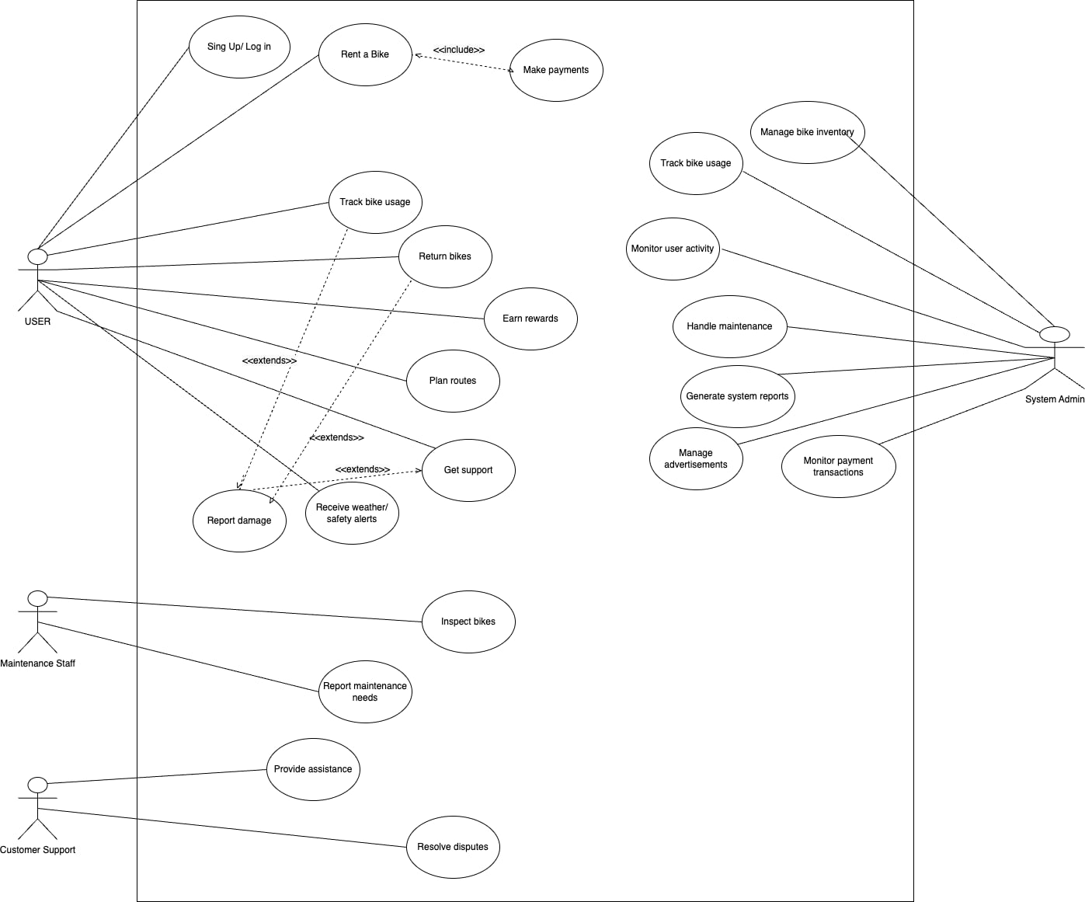

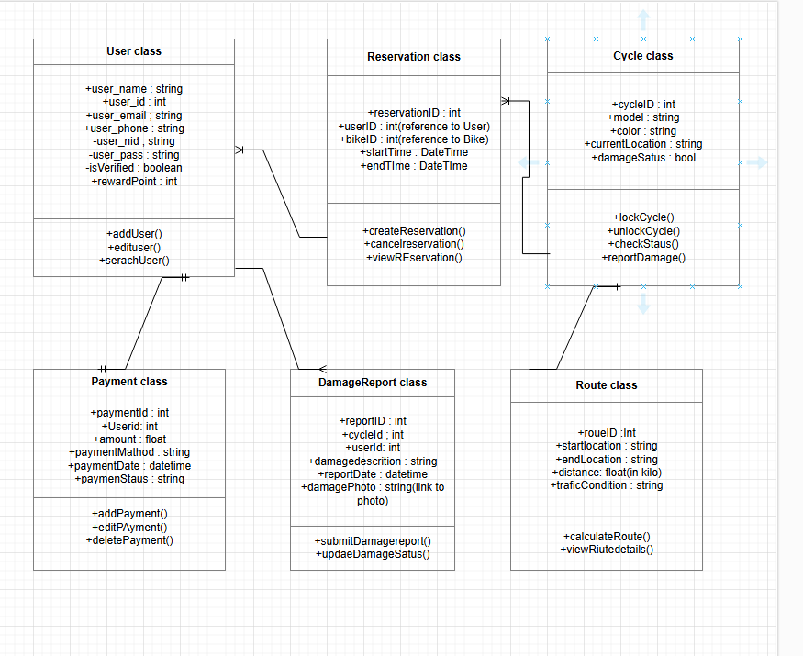**Class Diagram:**

Activity diagram:

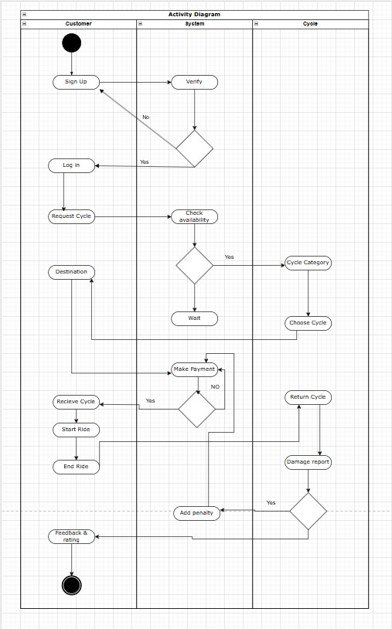

**Sequence Diagram:**

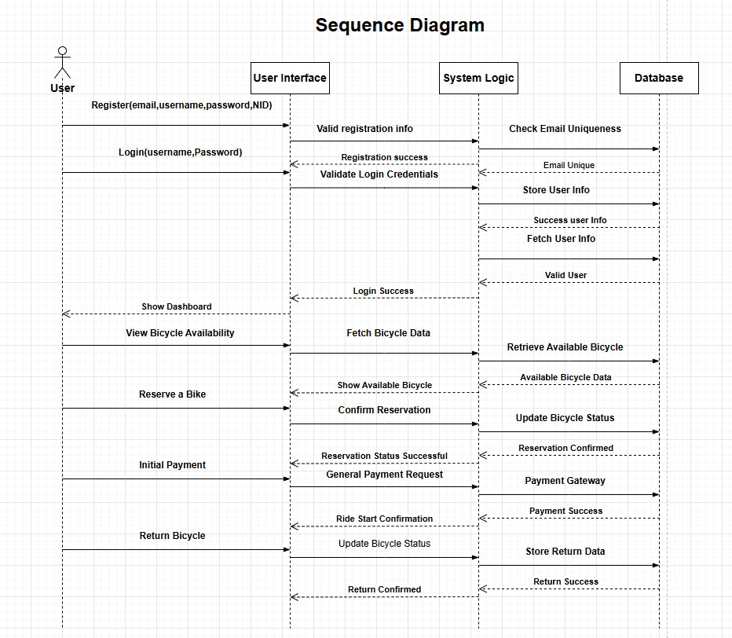

**Mobile App Design:**

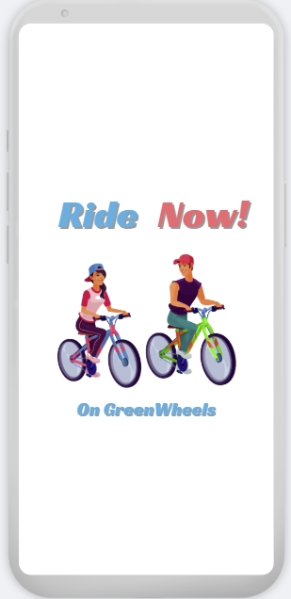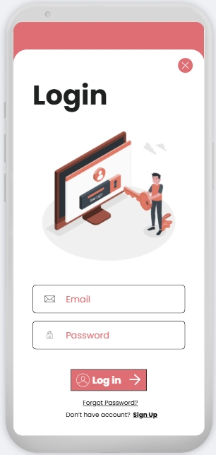

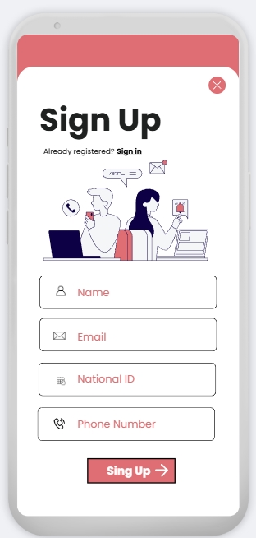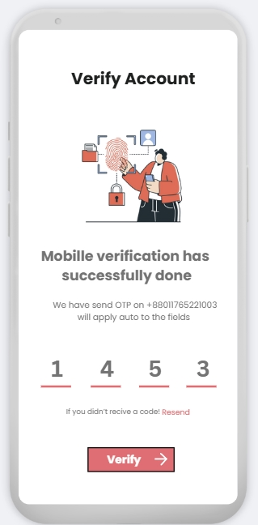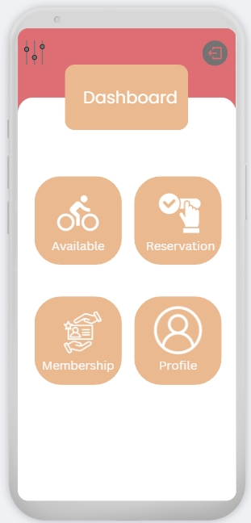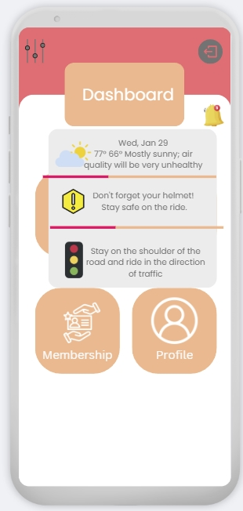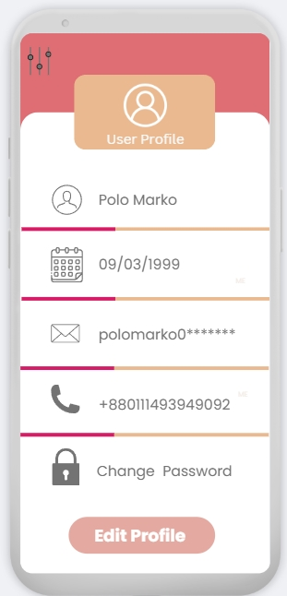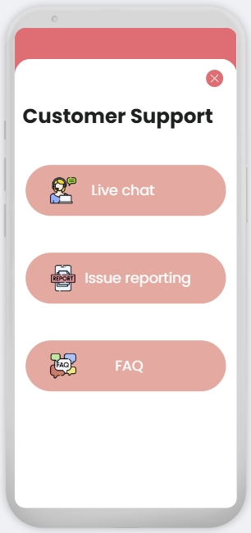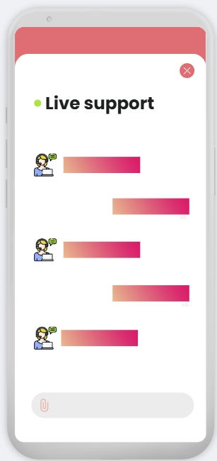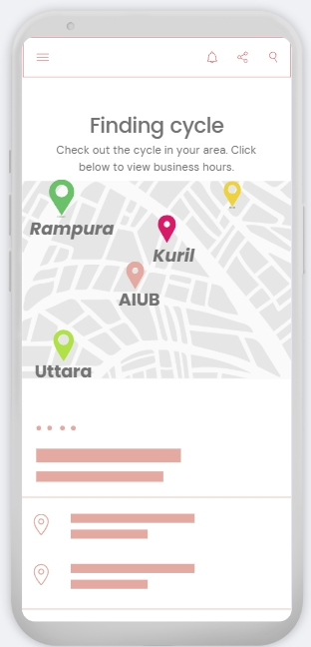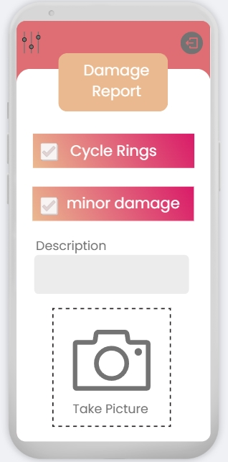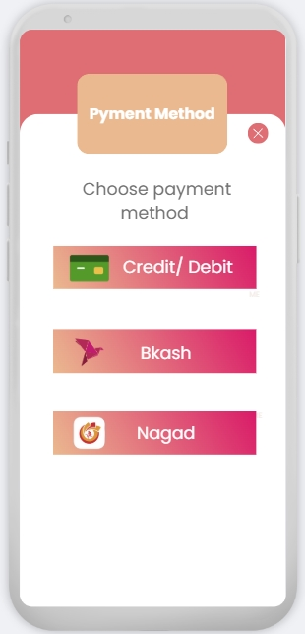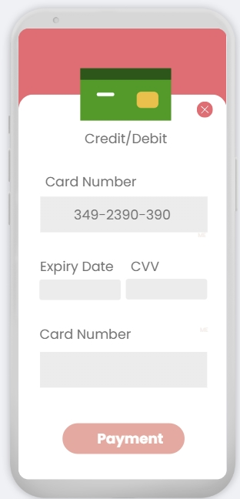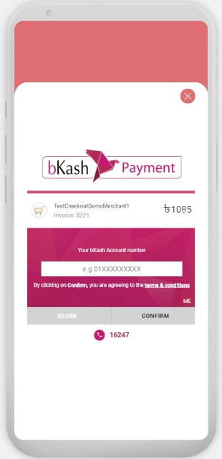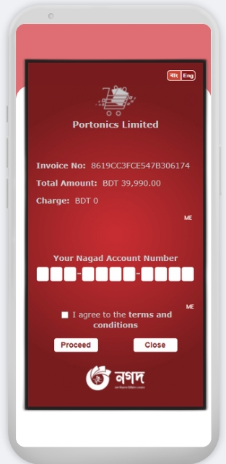

**Test modeling use case**

The test cases in our project emphasize the essential functionalities of the "Bicycle Rent Management System" and how they ensure a seamless user experience. Features like the registration and login processes are designed to securely validate user credentials, providing a smooth onboarding experience. GPS tracking and return station locators stand out by offering real-time navigation and availability updates, enhancing convenience for users. Additionally, the damage reporting functionality, which includes photo uploads, ensures transparency and accountability. The payment processing feature is particularly vital, as it provides secure and flexible transaction options. These test cases showcase that reliable and efficient system that aligns with the goal of promoting sustainable and accessible transportation.

# Test Case: Registration Functionality

|  |  |  |  |  |  |
| --- | --- | --- | --- | --- | --- |
| Project Name: Bicycle Rent Management | | | Test Designed by: Md. Al-Imran Sayem | | |
| Test Case ID: 1 | | | Test Designed date:11-12-2024 | | |
| Test Priority (Low, Medium, High): High | | | Test Executed by: | | |
| Module Name: Sign-up Session | | | Test Execution date: | | |
| Test Title: verify Sign-up with valid Email, Phone Number and National ID(NID) | | | | | |
| Description: Test website Sign-up page | | | | | |
| Precondition (If any): User must have valid Username, Email, Phone Number, National ID(NID) and password | | | | | |
| Test Steps | Test Data | Expected Results | | Actual Results | Status (Pass/Fail) |
| 1. Go to the   website   1. Enter username 2. Enter password 3. Click submit | Username: Rana  [Email:axxx@](mailto:axxx@gmail.com) [gmail.com](mailto:axxx@gmail.com)  Phone Number: 01********  National ID:*********  ***  Password: R23v#$125 | User should Sign-up into the application | |  |  |
| Post Condition: User is validated with database and successfully login to account. The account session details are logged in the database. | | | | | |

# Test Case: Login Functionality

|  |  |  |  |  |  |
| --- | --- | --- | --- | --- | --- |
| Project Name: Bicycle Rent Management | | | Test Designed by: Md. Al-Imran Sayem | | |
| Test Case ID: 2 | | | Test Designed date:11-12-2024 | | |
| Test Priority (Low, Medium, High): High | | | Test Executed by: | | |
| Module Name: Login Session | | | Test Execution date: | | |
| Test Title: Verify login with valid username and password | | | | | |
| Description: Test login functionality | | | | | |
| Precondition (If any): User must have a valid username, number/email and password | | | | | |
| Test Steps | Test Data | Expected Results | | Actual Results | Status (Pass/Fail) |
| 1. Go to login page 2. Enter valid username, number/email 3. Enter password 4. Click login button | Username: Rana  [Email:axxx@](mailto:axxx@gmail.com) [gmail.com](mailto:axxx@gmail.com)  Phone Number: 01********  Password: R23v#$125 | User is directed to login page  System accepts credentials  User successfully logs into the system | |  |  |
| Post Condition: User session is established. | | | | | |

# Test Case: Bicycle Booking

|  |  |  |  |  |  |
| --- | --- | --- | --- | --- | --- |
| Project Name: Bicycle Rent Management | | | Test Designed by: Md. Al-Imran Sayem | | |
| Test Case ID: 3 | | | Test Designed date:11-12-2024 | | |
| Test Priority (Low, Medium, High): High | | | Test Executed by: | | |
| Module Name: Booking | | | Test Execution date: | | |
| Test Title: Verify bicycle booking functionality | | | | | |
| Description: Test booking a bicycle for a valid user | | | | | |
| Precondition (If any): User must be logged in | | | | | |
| Test Steps | Test Data | Expected Results | | Actual Results | Status (Pass/Fail) |
| 1. Navigate to booking page 2. Select a bicycle 3. Enter password 4. Confirm booking | User ID: 101  Bicycle ID: B001  Booking Date: 2024-12-12 | Booking page opens successfully  Selected bicycle appears in booking cart  Confirmation message shown | |  |  |
| Post Condition: Bicycle is reserved for the user. | | | | | |

# Test Case: GPS-Enabled Tracking

|  |  |  |  |  |  |
| --- | --- | --- | --- | --- | --- |
| Project Name: Bicycle Rent Management | | | Test Designed by: MD. ABRAR RAFID SHARIAR | | |
| Test Case ID: 4 | | | Test Designed date:11-12-2024 | | |
| Test Priority (Low, Medium, High): High | | | Test Executed by: | | |
| Module Name: Payment Processing | | | Test Execution date: | | |
| Test Title: Verify GPS tracking functionality during bike usage | | | | | |
| Description: Test if the bicycle's location is accurately tracked. | | | | | |
| Precondition (If any): User must have an active booking. | | | | | |
| Test Steps | Test Data | Expected Results | | Actual Results | Status (Pass/Fail) |
| 1. Start a bicycle ride 2. Move the bicycle to another location 3. Check the app dashboard | Booking ID: 102  Distance traveled: 1km  N/A | GPS location starts tracking in real-time.  GPS accurately updates location on the map.  The updated GPS location is displayed | |  |  |
| Post Condition: Bicycle's real-time location is successfully recorded. | | | | | |

# Test Case: Damage Reporting and Photo Upload

|  |  |  |  |  |  |
| --- | --- | --- | --- | --- | --- |
| Project Name: Bicycle Rent Management | | | Test Designed by: MD. ABRAR RAFID SHARIAR | | |
| Test Case ID: 5 | | | Test Designed date:11-12-2024 | | |
| Test Priority (Low, Medium, High): High | | | Test Executed by: | | |
| Module Name: Damage Reporting | | | Test Execution date: | | |
| Test Title: Verify damage reporting with photo upload | | | | | |
| Description: Test if users can report damages before or after a ride. | | | | | |
| Precondition (If any): User has rented a bicycle. | | | | | |
| Test Steps | Test Data | Expected Results | | Actual Results | Status (Pass/Fail) |
| A. Open the damage report form  B. Upload a photo of damage  C. Submit damage report | Report Type: Before Ride  Image: scratch.png  Description: Brake not working. | Description: Brake not working.  Photo upload is successful.  Confirmation message is displayed. | |  |  |
| Post Condition: Damage report is recorded, and photo evidence is stored. | | | | | |

# Test Case: In-App Customer Support

|  |  |  |  |  |  |
| --- | --- | --- | --- | --- | --- |
| Project Name: Bicycle Rent Management | | | Test Designed by: S.M. RASEL | | |
| Test Case ID: 6 | | | Test Designed date:11-12-2024 | | |
| Test Priority (Low, Medium, High): High | | | Test Executed by: | | |
| Module Name: Customer Support | | | Test Execution date: | | |
| Test Title: Verify in-app live chat functionality | | | | | |
| Description: Test the availability of live chat for user issues. | | | | | |
| Precondition (If any): User is logged in to the app. | | | | | |
| Test Steps | Test Data | Expected Results | | Actual Results | Status (Pass/Fail) |
| A. Access the live chat option  B. Type and send a message  C. Resolve the issue | Issue Type: “Payment issue”  “My payment failed, help!”  Resolution: Retry Payment  . | Chat window opens.  Customer support agent responds promptly.  Issue is marked resolved with confirmation. | |  |  |
| Post Condition: User receives support, and the issue status is updated. | | | | | |

# Test Case: Return Station Locator

|  |  |  |  |  |  |
| --- | --- | --- | --- | --- | --- |
| Project Name: Bicycle Rent Management | | | Test Designed by: S.M. RASEL | | |
| Test Case ID: 7 | | | Test Designed date:11-12-2024 | | |
| Test Priority (Low, Medium, High): High | | | Test Executed by: | | |
| Module Name: Return Station Locator | | | Test Execution date: | | |
| Test Title: Verify the nearest return station locator | | | | | |
| Description: Test if users can locate the nearest return station. | | | | | |
| Precondition (If any): User has a bicycle to return. | | | | | |
| Test Steps | Test Data | Expected Results | | Actual Results | Status (Pass/Fail) |
| A. Open the return station locator  B. View real-time availability  C. Get GPS directions | User  Location: GPS enabled  Dock Availability: 3 Slots  Return Station ID: RS-05 | App shows the nearest return stations.  Station details (slots, distance) are displayed.  GPS navigation to the station starts. | |  |  |
| Post Condition: User can successfully locate and navigate to the nearest return station. | | | | | |

# Test Case: In-App Route Planner

|  |  |  |  |  |  |
| --- | --- | --- | --- | --- | --- |
| Project Name: Bicycle Rent Management | | | Test Designed by: MD. TANJIL TASHRIK ZIM | | |
| Test Case ID: 8 | | | Test Designed date:11-12-2024 | | |
| Test Priority (Low, Medium, High): High | | | Test Executed by: | | |
| Module Name: Route Planner | | | Test Execution date: | | |
| Test Title: Verify route planning with traffic avoidance | | | | | |
| Description: Verify route planning with traffic avoidance | | | | | |
| Precondition (If any): User has an active booking. | | | | | |
| Test Steps | Test Data | Expected Results | | Actual Results | Status (Pass/Fail) |
| A. Access the route planner  B. Check traffic avoidance  C. Follow suggested route | Start Point: Hub A, Destination: Hub B  Traffic Data: High Congestion    N/A | App generates an optimal cycling route.  Route avoids heavy traffic zones.  Directions match the optimized route plan. | |  |  |
| Post Condition: User receives a traffic-optimized route. | | | | | |

# Test Case: Weather and Safety Notifications

|  |  |  |  |  |  |
| --- | --- | --- | --- | --- | --- |
| Project Name: Bicycle Rent Management | | | Test Designed by: MD. TANJIL TASHRIK ZIM | | |
| Test Case ID: 9 | | | Test Designed date:11-12-2024 | | |
| Test Priority (Low, Medium, High): High | | | Test Executed by: | | |
| Module Name: Notifications | | | Test Execution date: | | |
| Test Title: Verify real-time weather and safety alerts | | | | | |
| Description: Test if users are notified about sudden weather or safety updates. | | | | | |
| Precondition (If any): User has the app notifications enabled. | | | | | |
| Test Steps | Test Data | Expected Results | | Actual Results | Status (Pass/Fail) |
| 1. Trigger weather alert 2. Trigger safety reminder 3. Suggest alternatives | Suggest alternatives  Safety:  Heavy Traffic Nearby  Option: Nearest shelter | App sends weather notification: Rain Alert.  App sends safety notification: Avoid main roads.  App suggests safe areas or other options. | |  |  |
| Post Condition: Users receive accurate, real-time notifications. | | | | | |

# Test Case: Payment Processing

|  |  |  |  |  |  |
| --- | --- | --- | --- | --- | --- |
| Project Name: Bicycle Rent Management | | | Test Designed by: Abdullah Al Maruf | | |
| Test Case ID: 10 | | | Test Designed date:11-12-2024 | | |
| Test Priority (Low, Medium, High): High | | | Test Executed by: | | |
| Module Name: Payment Processing | | | Test Execution date: | | |
| Test Title: verify payment functionality with valid payment details | | | | | |
| Description: Test payment processing during booking | | | | | |
| Precondition (If any): User must have a valid payment method | | | | | |
| Test Steps | Test Data | Expected Results | | Actual Results | Status (Pass/Fail) |
| 1. Navigate to payment page 2. Enter payment details 3. Confirm payment | Card Number: 1234-5678-9012-3456  Expire: 12/26, CVV: 123  Amount: 500BDT | Payment page opens successfully  Payment is processed  Confirmation message is displayed | |  |  |
| Post Condition: Payment is processed and logged in the database. | | | | | |

# Test Case: Return Functionality

|  |  |  |  |  |  |
| --- | --- | --- | --- | --- | --- |
| Project Name: Bicycle Rent Management | | | Test Designed by: Abdullah Al Maruf | | |
| Test Case ID: 11 | | | Test Designed date:11-12-2024 | | |
| Test Priority (Low, Medium, High): High | | | Test Executed by: | | |
| Module Name: Return Functionality | | | Test Execution date: | | |
| Test Title: verify bicycle return functionality | | | | | |
| Description: Test returning a bicycle | | | | | |
| Precondition (If any): User must have an active booking | | | | | |
| Test Steps | Test Data | Expected Results | | Actual Results | Status (Pass/Fail) |
| 1. Navigate to return page 2. Enter bicycle details 3. Confirm return | User ID:101  Bicycle ID: B001 | Return page opens successfully  Bicycle return request is accepted  Confirmation message is displayed | |  |  |
| Post Condition: Bicycle return is recorded in the system | | | | | |

**Work Breakdown Structure (WBS):**

**COCOMO Calculation:**

PM: person-months needed for project (labor working hours)

PM = Coefficient<Effort Factor>*(SLOC/1000)^P

= 2.4*(5000/1000)^1.05

= 13.0055

DM: duration time in months for project (week days)

DM = 2.50*(PM)^T

=2.50*(13.006)^0.38

= 6.627

ST: average staffing necessary

ST = PM/DM = 1.96 =2

**Time Line Chart 01:**

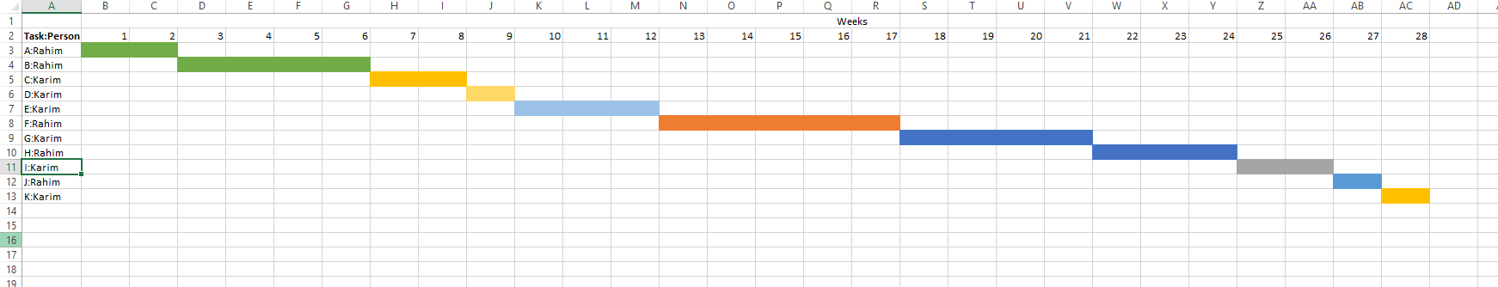

A: Rahim----Communication F: Rahim------Overall designing

B: Rahim-----Project Initialization& Requirement gathering G: Karim------ All Code module

C: Karim-----Planning H: Rahim------Testing

D: Karim-----Estimating I: Karim------Delivery

E: Karim------ Scheduling & Tracking J: Rahim------Support

K: Karim-----Feedback

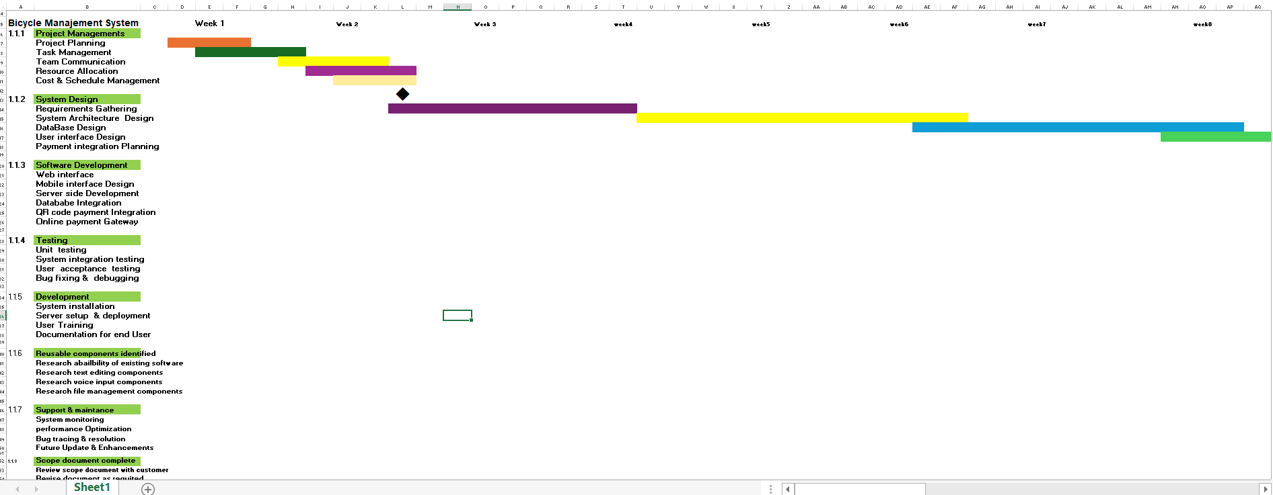**Timeline Chart-2**

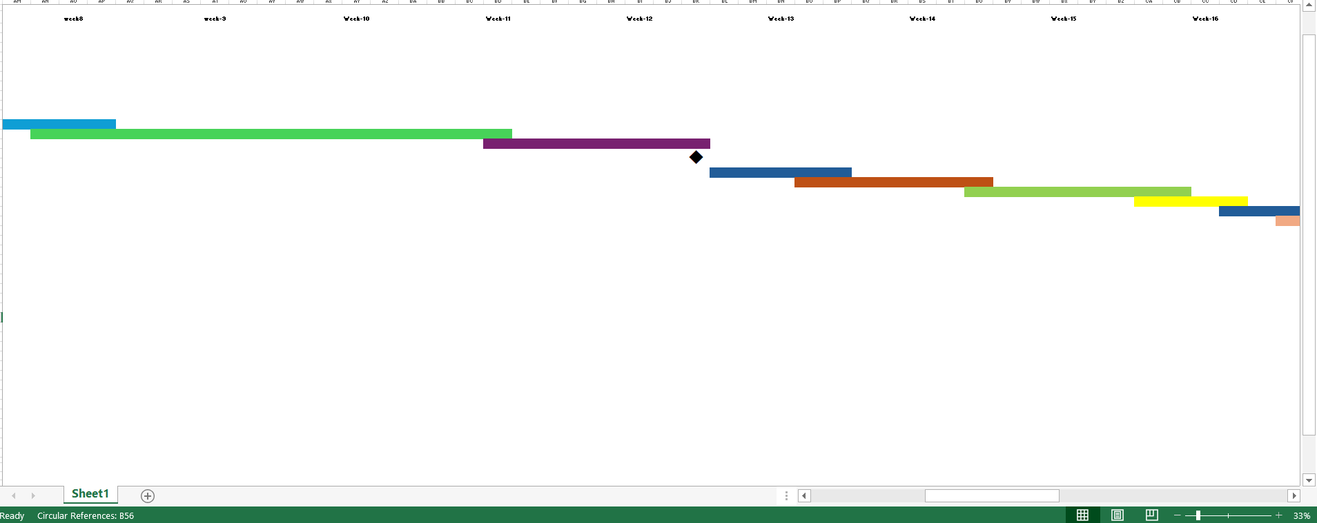

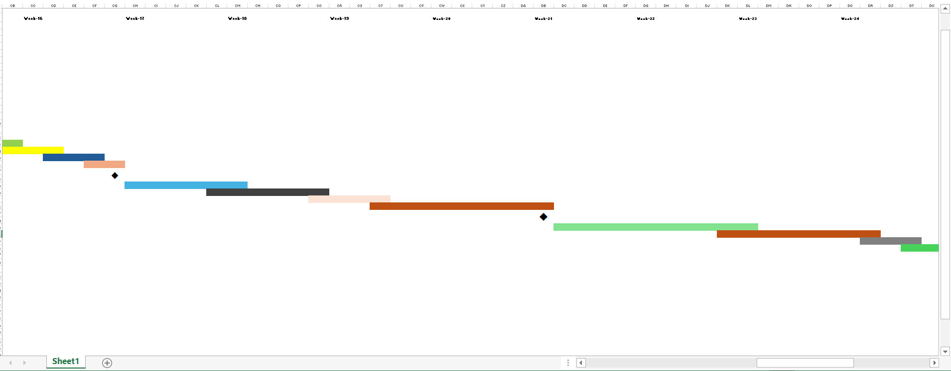

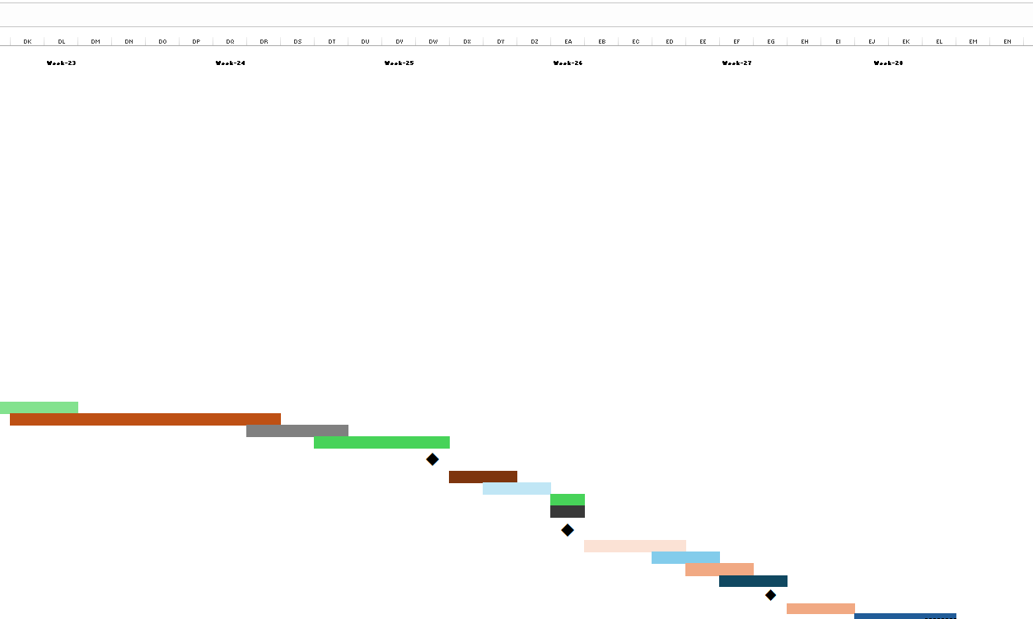

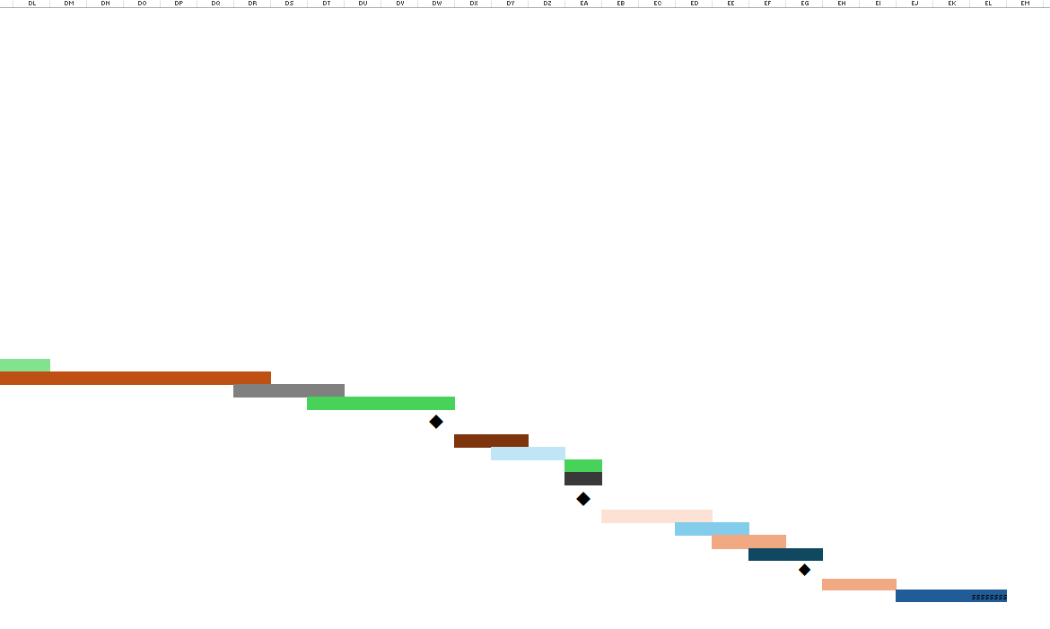

**Excel File: **

**EVA Calculation:**

|  |  |  |
| --- | --- | --- |
| Task | Planned | Actual Effort |
| 1 | 3 | 5 |
| 2 | 4 | 4.5 |
| 3 | 4 | 6 |
| 4 | 4 | 3 |
| 5 | 3 | 4.5 |
| 6 | 9 | 10.5 |
| 7 | 12 | 12.5 |
| 8 | 12 | 13 |
| 9 | 17 | 17 |
| 10 | 8 | 9 |

**Total Task = 10 BCWP = 51 BCWS = 76 ACWP = 59**

* **BAC = 286.12**
* **SPI = BCWP / BCWS = 51 / 76 = 0.671**
* **SV = BCWP – BCWS = 51- 76 = -25 person-days**
* **CPI = BCWP /ACWP = 51 / 59 = 0.865**
* **CV = BCWP -ACWP = 51 – 59 = -8 person-days**

% schedule for completion = **BCWS / BAC = = 26.562%**

* [% of work scheduled to be done at this time]

% complete = **BCWP / BAC = = 17.82%**

[% of work completed at this time]

# Risk Management Plan

## Building Risk Table

The following table outlines the risks identified for the Bicycle Rent Management System, categorized by type, with their probabilities, impacts, and RMMM strategies. The impact values are defined as: 1—catastrophic, 2—critical, 3—marginal, and 4—negligible.

|  |  |  |  |  |
| --- | --- | --- | --- | --- |
| Risks | Category | Probability (%) | Impact | RMMM |
| Low initial adoption rate by users | Customer (CU) | 50% | 3 | Run targeted marketing campaigns to increase awareness and adoption. |
| System downtime or technical glitches during high traffic | Technology (TE) | 60% | 1 | Conduct thorough load testing and maintain a scalable infrastructure. |
| Inaccurate GPS tracking of bicycles | Technology (TE) | 40% | 2 | Use high-quality GPS modules and perform frequent testing. |
| Delayed app development impacting launch | Project Schedule (PS) | 30% | 2 | Implement Agile development and conduct regular progress reviews. |
| Lack of user trust in digital payment security | Customer (CU) | 50% | 2 | Adopt industry-standard encryption and transparent security policies. |
| Unavailability of bicycles at key locations | Operations (OP) | 70% | 3 | Utilize demand forecasting and implement a real-time tracking system. |
| Insufficient maintenance leading to bike breakdowns | Operations (OP) | 60% | 2 | Implement predictive maintenance schedules and usage monitoring. |
| Resistance from local authorities on bike parking policies | Regulatory (RG) | 40% | 3 | Engage local authorities early and ensure compliance with regulations. |
| High competition from similar services | Market (MK) | 50% | 3 | Focus on unique features, competitive pricing, and superior service. |
| Difficulty in recruiting experienced staff for operations | Staffing (ST) | 30% | 2 | Offer competitive salaries, training programs, and career development. |

Conclusion

The "Bicycle Rent Management System" project successfully addresses critical urban challenges by offering a sustainable, efficient, and user-centered transportation solution. By integrating advanced technologies such as GPS tracking, digital payments, and predictive maintenance, the system promotes eco-friendly travel while enhancing user convenience and safety. Features like flexible rental options, multilingual support, and comprehensive risk management ensure broad accessibility and reliability. This project not only fulfills its initial objectives but also paves the way for continuous improvement and expansion, supporting the vision of a more connected and sustainable urban environment.